Lab Report No 7



**Digital Signal Processing**

**Submitted By: Muhammad Umar Jan**

**Registration No: 21PWCSE2000**

**Section: B**

“On my honor , as student of University of Engineering and Technology, I have neither given nor received unauthorized assistance on this academic work”

Student Signature:

Department of Computer Systems Engineering

University of Engineering and Technology Peshawar

**CSE 402L: Digital Signal Processing**

|  |  |  |  |  |
| --- | --- | --- | --- | --- |
| **Demonstration of Concepts** | **Poor (Does not meet expectation (1))**  The student failed to demonstrate a clear understanding of the assignment concepts | **Fair (Meet Expectation (2-3))**  The student demonstrated a clear understanding of some of the assignment concepts | **Good (Exceeds Expectation (4-5)**  The student demonstrated a clear understanding of the assignment concepts | **Score**  **30%** |
| **Accuracy** | The student completed ( <50%) tasks and provided MATLAB code and/or Simulink models with errors. Outputs shown are not correct in form of graphs (no labels) and/or tables along with incorrect analysis or remarks. | The student completed partial tasks (50% - <90%) with accurate MATLAB code and/or Simulink models. Correct outputs are shown in form of graphs (without labels) and/or tables along with correct analysis or remarks. | The student completed all required tasks (90%-100%) with accurate MATLAB code and/or Simulink models. Correct outputs are shown in form of labeled graphs and/or tables along with correct analysis or remarks. | **30%** |
| **Following Directions** | The student clearly failed to follow the verbal and written instructions to successfully complete the lab | The student failed to follow the some of the verbal and written instructions to successfully complete all requirements of the lab | The student followed the verbal and written instructions to successfully complete requirements of the lab | **20%** |
| **Time Utilization** | The student failed to complete even part of the lab in the allotted amount of time | The student failed to complete the entire lab in the allotted amount of time | The student completed the lab in its entirety in the allotted amount of time | **20%** |

Lab No: 7.

## Title: Implemention/Analysis of Frequency Modulated and Demodulated Signal using Matlab

A sine wave carrier can be modified for the purpose of transmitting information from one place to another by varying its frequency. This is known as **frequency modulation (FM).**

Frequency modulation (FM) is the standard technique for high-fidelity communications as is evident in the received signals of the FM band (88-108 MHz) vs. the AM band (450-1650 KHz). The main reason for the improved fidelity is that FM detectors, when properly designed, are not sensitive to random amplitude variations which are the dominant part of electrical noise (heard as static on the AM radio). Frequency modulation is not only used in commercial radio broadcasts, but also in police and hospital communications, emergency channels, TV sound, wireless (cellular) telephone systems.



νAM = *Vc*sin 2π*fct* + (*Vm*sin 2π*fmt*)(sin 2π*fct*)

Task:

**fs = 1000;**

**t = 0:1/fs:0.2;**

**carrierfreq = 200;**

**f1 = 30;**

**f2 = 60;**

**fdev = 50;**

**fdevl = 100;**

**x1 = sin(2*pi*f1*t);**

**x2 = sin(2*pi*f2*t);**

**x = x1 + x2;**

**carrier_signal = sin(2*pi*carrierfreq*t);**

**mod_signal = fmmod(x, carrierfreq, fs, fdev);*%Modulated Signal with 50 m_index***

**mod_signal_2 = fmmod(x, carrierfreq, fs, fdevl);*%m_sig with 100 m_index***

**demod_signal = fmdemod(mod_signal, carrierfreq, fs, fdev);*%Demodulating***

**figure(1);**

**hold on;**

**plot(t, x, 'k', 'LineWidth', 2); *%Plotting carrier and original Signal***

**plot(t, carrier_signal, 'b', 'LineWidth', 2);**

**hold off;**

**xlabel('Time (seconds)');**

**ylabel('Amplitude');**

**title('Original and Carrier Signals');**

**legend('Original Signal', 'Carrier Signal');**

**grid on;**

**figure(2);**

**hold on;**

**plot(t, x, 'c', 'LineWidth', 2);*%Plotting Modulated and original Signal***

**plot(t, mod_signal, 'g', 'LineWidth', 2);*%With modulating index = 50***

**hold off;**

**axis([0, 0.2, -4, 4]);**

**xlabel('Time (seconds)');**

**ylabel('Amplitude');**

**title('Original and Modulated Signals');**

**legend('Original Signal', 'Modulated Signal (fdev=50)');**

**grid on;**

**figure(3);**

**hold on;**

**plot(t, x, 'm', 'LineWidth', 2); *%Plotting Modulated and original Signal***

**plot(t, mod_signal_2, 'r', 'LineWidth', 2);*%Modulating Index = 100***

**hold off;**

**axis([0, 0.2, -4, 4]);**

**xlabel('Time (seconds)');**

**ylabel('Amplitude');**

**title('Original and Modulated Signals');**

**legend('Original Signal', 'Modulated Signal (fdev=100)');**

**grid on;**

**figure(4);**

**hold on;**

**plot(t, x, 'r', 'LineWidth', 2);*%Plotting DeModulated and original Signal***

**plot(t, demod_signal, 'k', 'LineWidth', 2);*%With modulating index = 50***

**hold off;**

**xlabel('Time (seconds)');**

**ylabel('Amplitude');**

**title('Original and Demodulated Signals');**

**legend('Original Signal', 'Demodulated Signal (fdev=50)');**

**grid on;**

Matlab Code for Modulating and Demodulating Signal

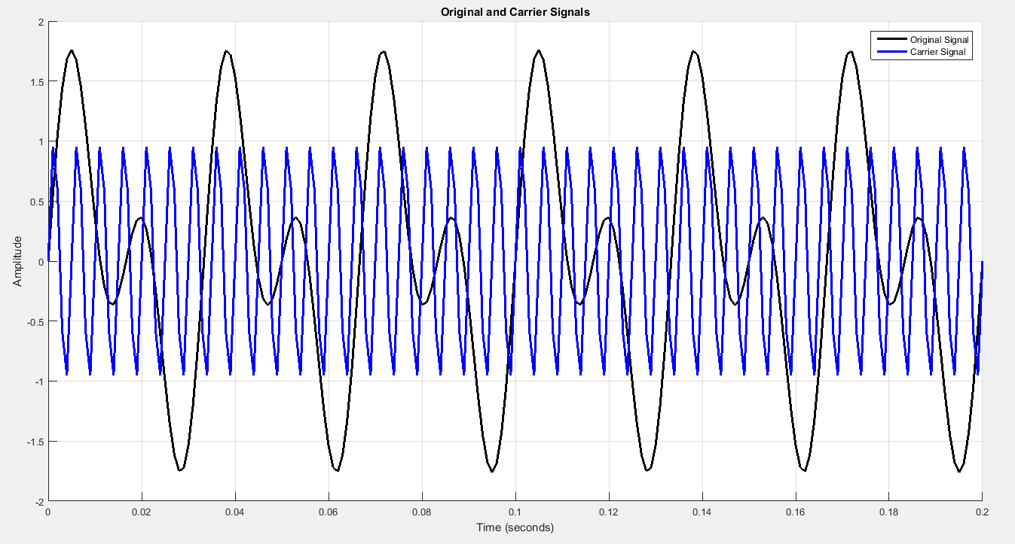

Figure 1: Modulating and Carrier Signal

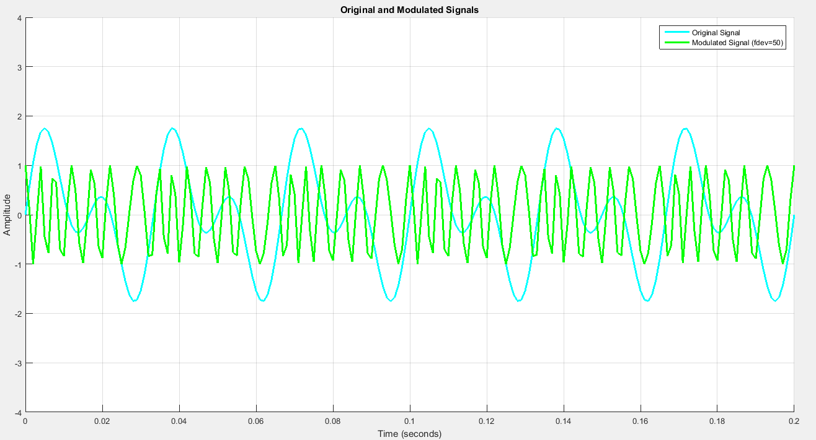

Figure 2: Modulating and Modulated Signal

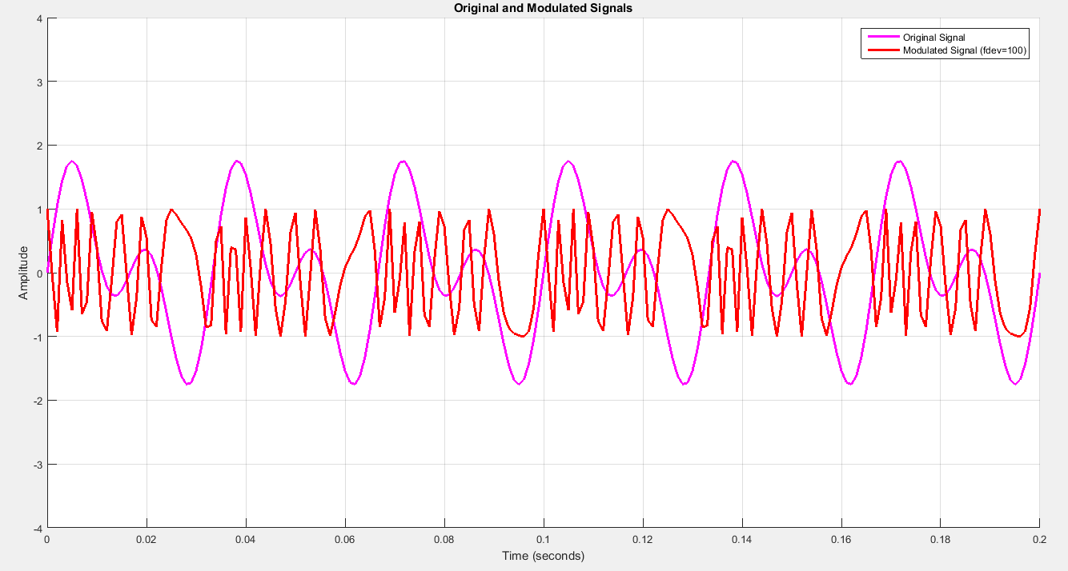

Figure 3: Modulating and Modulated Signal

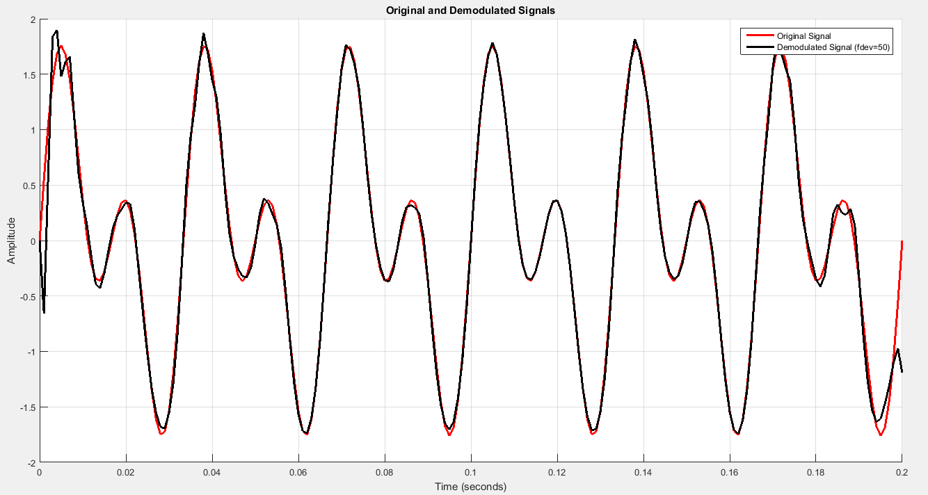Figure 4: Modulating and Demodulated Signal

**______________________________________________________________________________________________**